1. docker logs <container-id>
2. 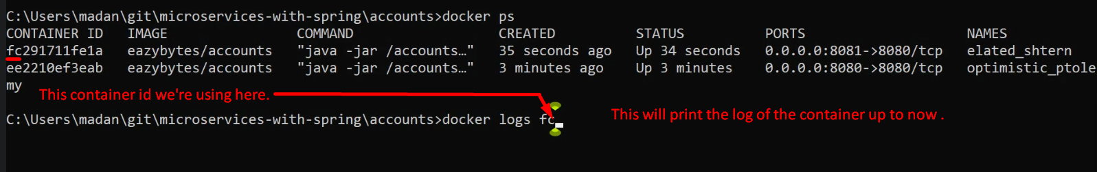
3. docker logs -f <container-id>  
   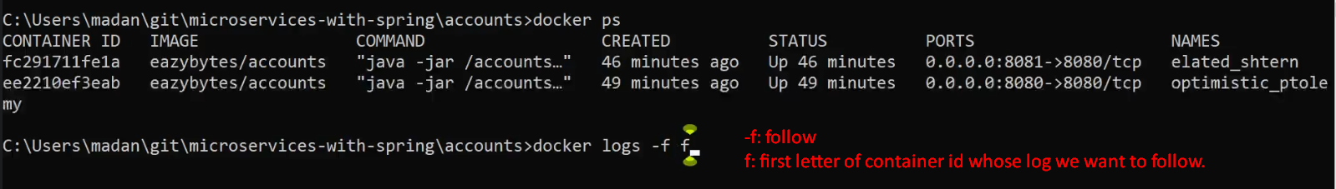
4. docker stop <container-id>  
   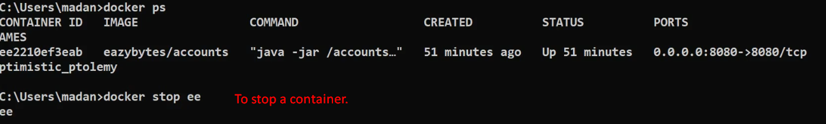
5. docker ps -a 🡺 -a: all either running or stopped.  
   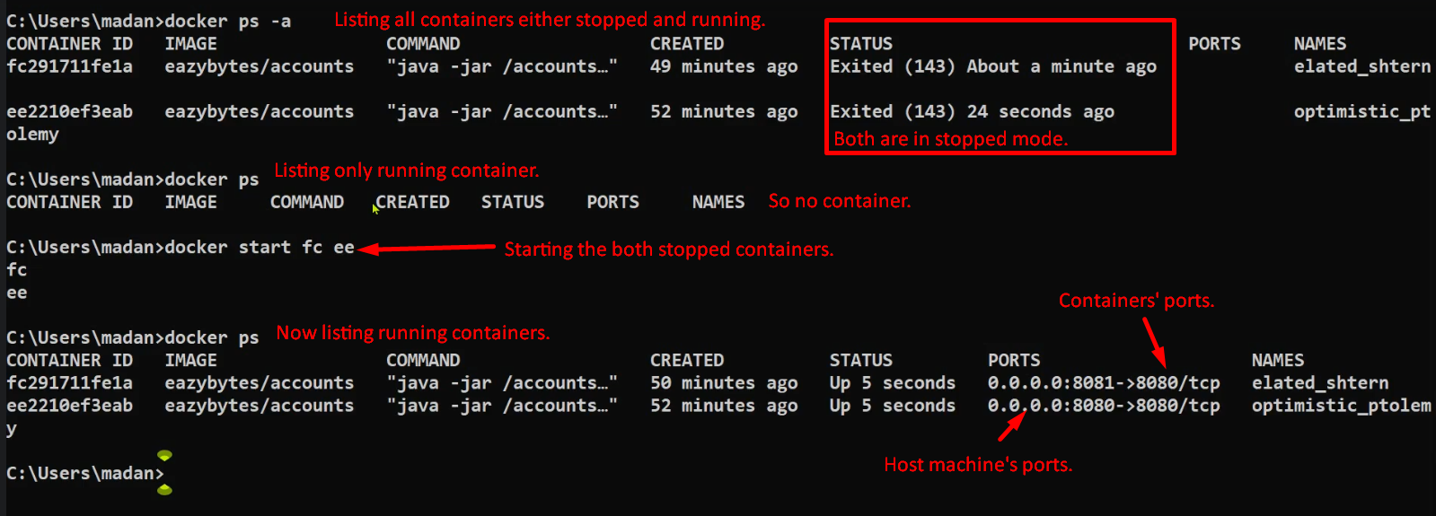
6. docker container pause <container-id>  
   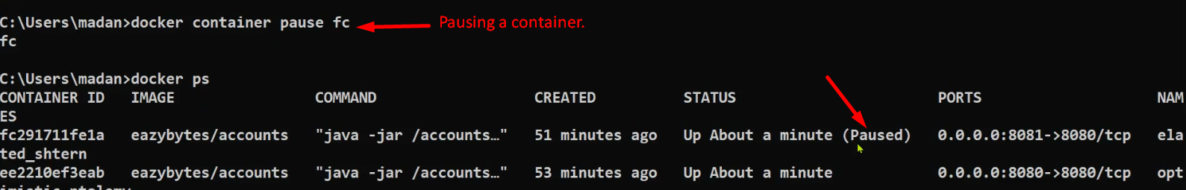
7. docker container unpause <container-id>

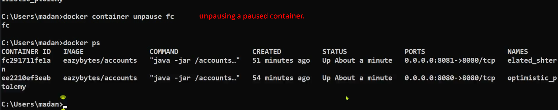

1. docker container inspect fc:  
   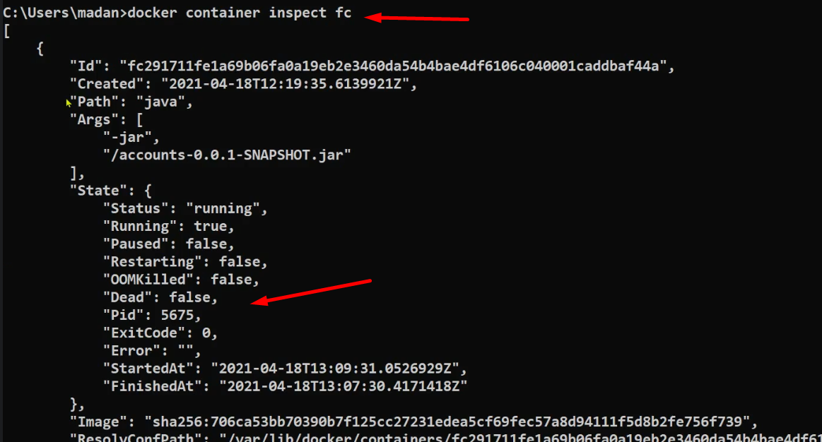
2. docker kill <container-id>
3. 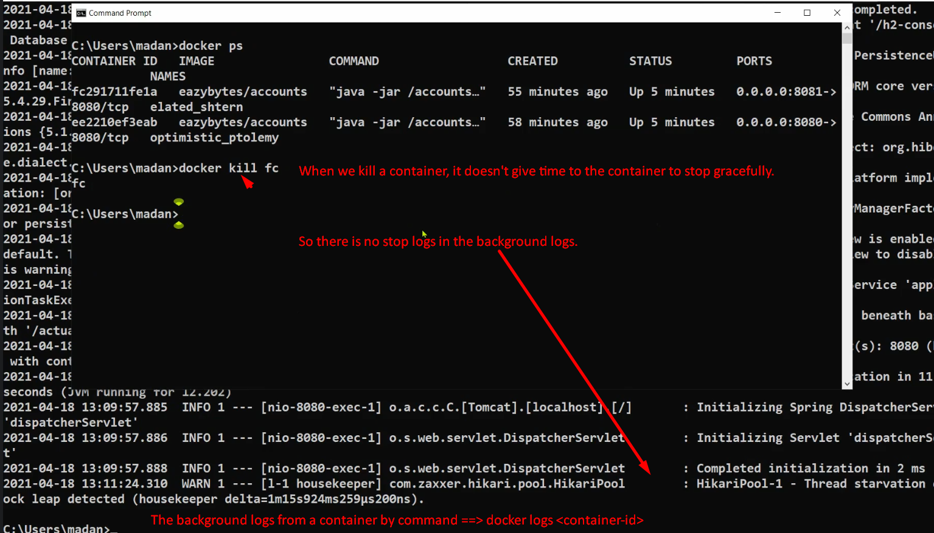
4. docker stats  
     
   
5. docker rm <container-id>  
   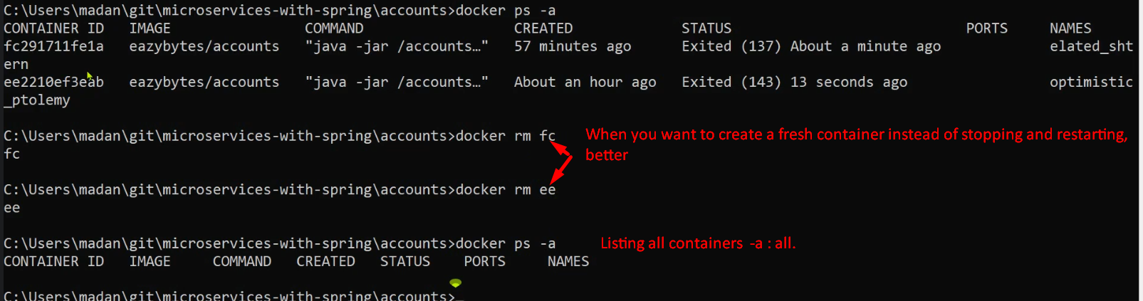
7. 